**Pre-Laboratory Questions**

1. List four major categories of biological macromolecules found in living things(1 point)

a. Proteins

b. Nucleic Acids

c. Carbohydrates

d. Lipids

1. Explain the difference between a monosaccharide and a polysaccharide.(.5 point)

Both monosaccharides and polysaccharides are carbohydrates, but they differ in many ways. Monosaccharides are the simplest form of carbohydrates, consisting of a single sugar molecule like glucose, fructose or dextrose. They serve as quick energy sources and are often eaten by athletes to replenish glycogen stores quickly. Polysaccharides are the opposite of this, being a complex carbohydrate made up of multiple monosaccharide units. They are used for energy storage and structural support. You will generally see an athlete eat these the day before a big event.

1. What biological macromolecules are made up of many amino acids joined by peptide bonds?(.5 point)

Proteins

1. How do lipids differ from carbohydrates?(.5 point)

Lipids are fats in a simple definition. They are fatty acids and glycerol. Lipids are not water soluble (try mixing olive oil with water), they are hydrophobic. Lipids are also 9 calories per gram while carbs are 4 calories per gram. Lipids function serve as long term energy storage and can have structural support, like making up cell membranes.

1. What is an enzyme? How do they aid in digestion? (.5 point)

Enzymes are proteins that acts as biological catalyst, so they speed up chemical reactions without having to be consumed. They break down carbs, proteins, and lipids into smaller and more manageable pieces that the body can absorb.

1. In the lipid test, what observation indicates a positive result for lipids?(.5 point)

In a common lipid test, a positive result typically is a change of color, often to red, indicating that lipids are present.

**Example Observations**

***Activity1: Starch Test (1 point)***

|  | **Observations** |
| --- | --- |
| **Test tube 1 $$Water+iodine potasium iodide$$** | The iodine potassium solution changed the color to orange |
| **Test tube 2 $$Water+potato starch+iodine potasium iodide$$** | Water became black, with the black settling at the bottom. |
| **Test tube 3 $$Water+albumin solution+iodine potasium iodide$$** | Same as test tube 1, but a more vibrant color |

**Activity 1 Image: Starch Test, Step 5**

## Image (2 points)

A required part of this laboratory experiment is to capture pictures of the experimental process and results. Click on the icon in the box below to include the required image for this lab.

**Note:** Failure to submit these images will result in a grade of zero for this lab.

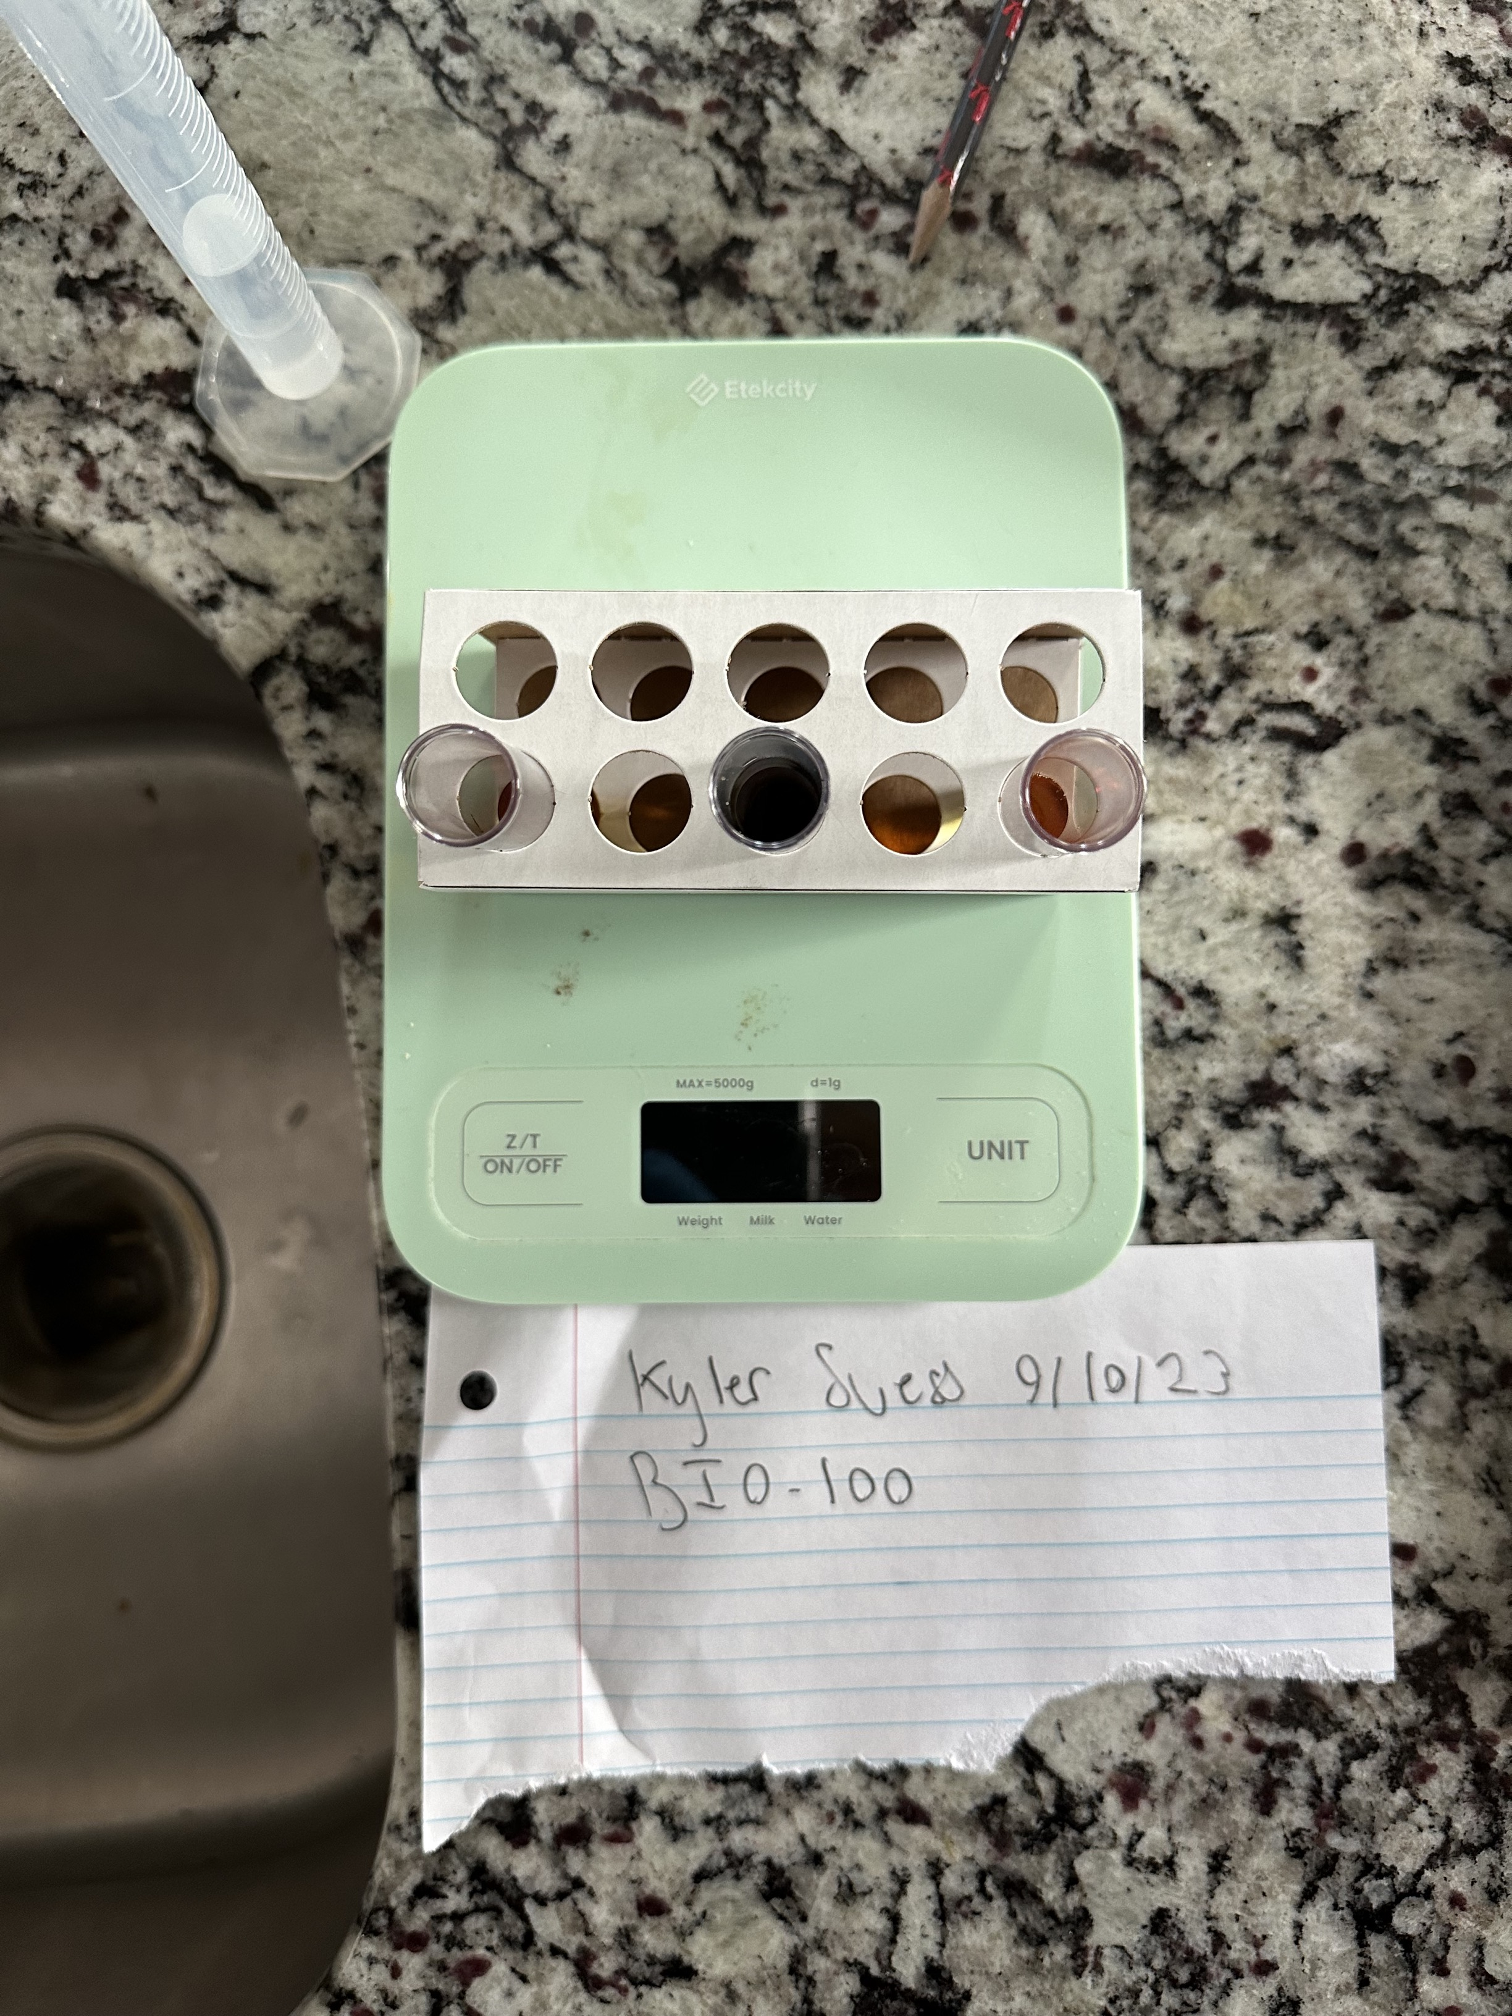

Results of starch test for Activity 1, Step 5

***Activity 2: Protein Test (1 point)***

|  | **Observations** |
| --- | --- |
| **Test tube 1 $$Water+Biuret reagent$$** | Took on the color of the Biuret reagent |
| **Test tube 2 $$Water+albumin solution+Biuret reagent$$** | Same as test tube 1, but took on a more saturated color |
| **Test tube 3 $$Water+potato starch solution+Biuret reagent$$** | The potato starch has settled at the bottom, then the Biuret, then water |

**Activity 2 Image: Protein Test, Step 5**

## Image (2 points)

A required part of this laboratory experiment is to capture pictures of the experimental process and results. Click on the icon in the box below to include the required image for this lab.

**Note:** Failure to submit these images will result in a grade of zero for this lab.

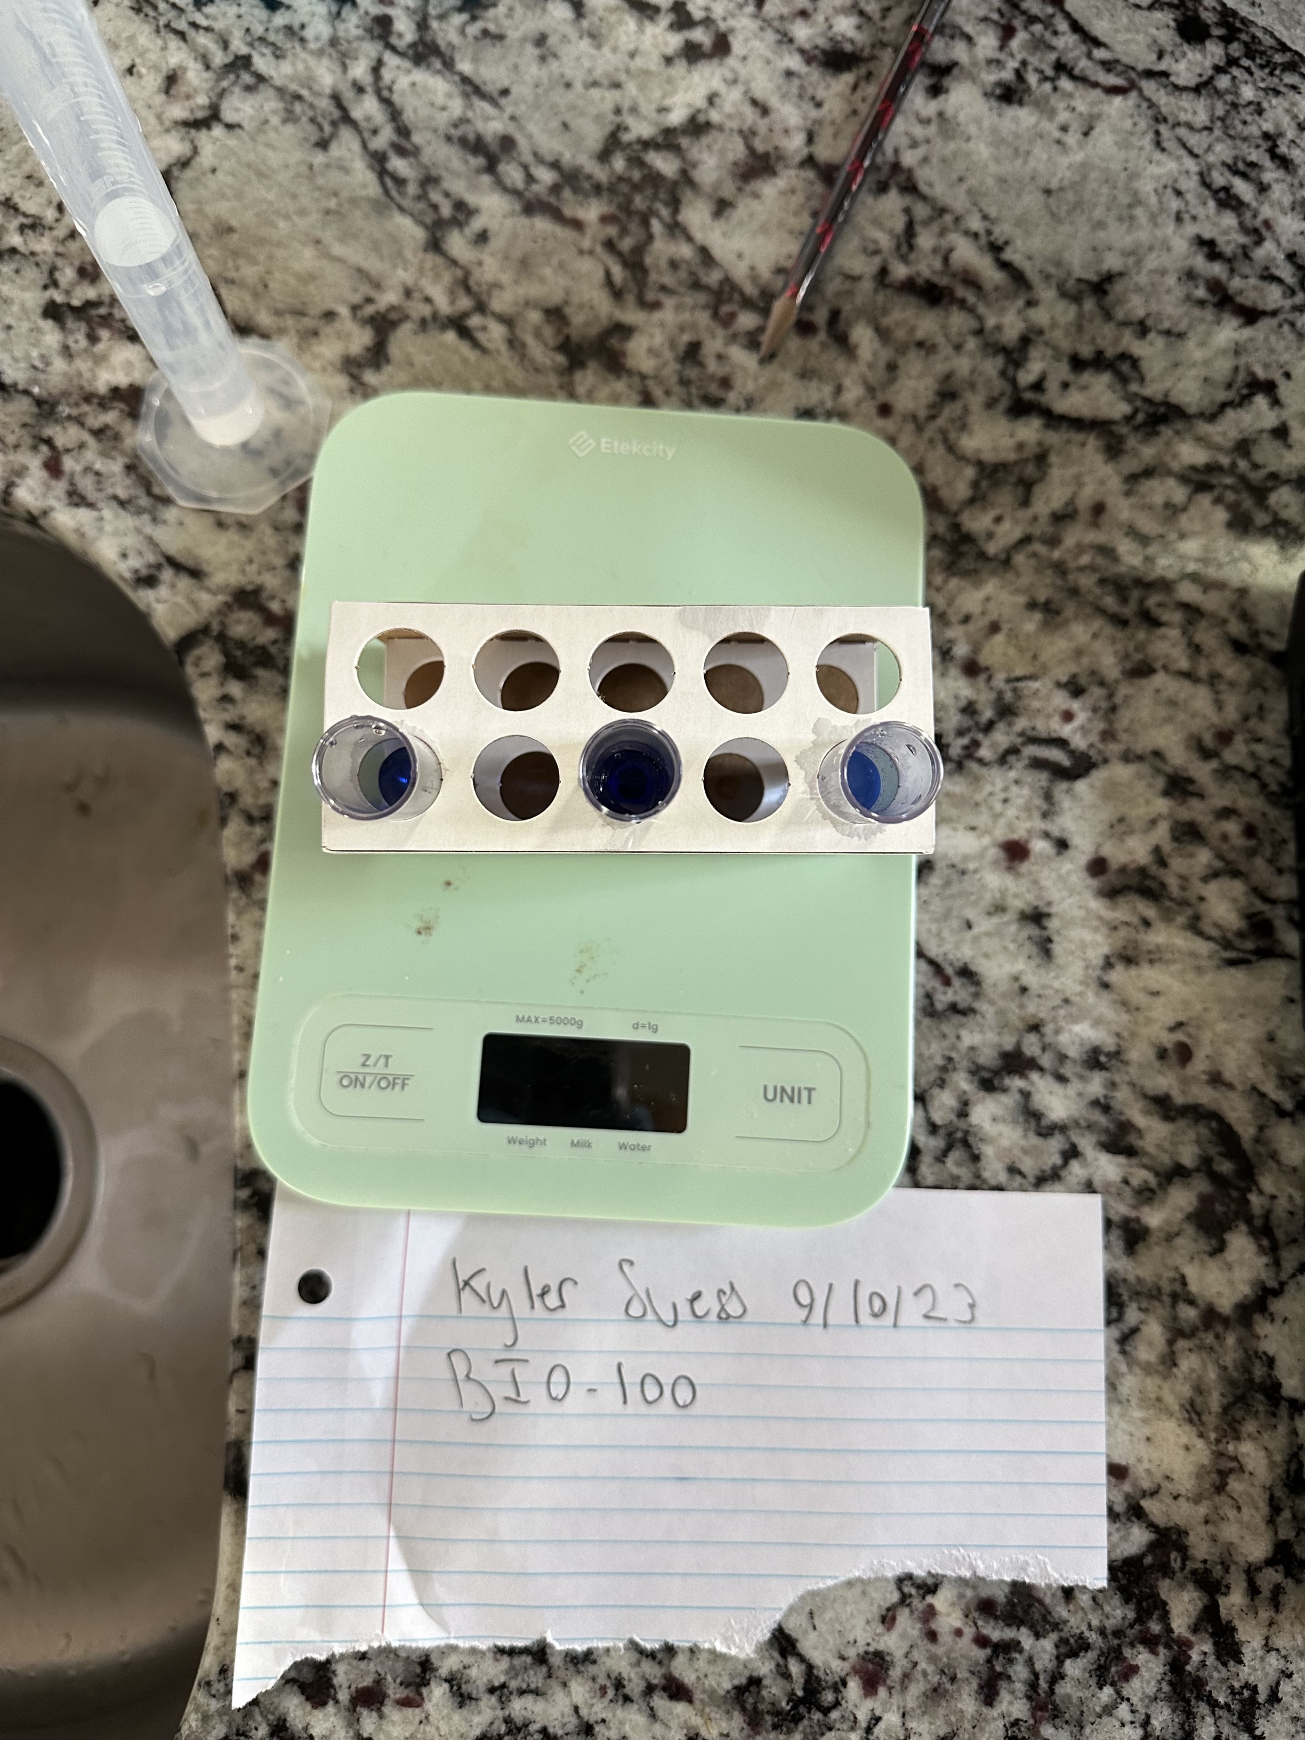

Results of protein test for Activity 2, Step 5

***Activity 3: Quick Test for Fats (1 point)***

|  | **Observation (+ or -)** |
| --- | --- |
| 1. **Water** | - , not translucent |
| 1. **Vegetable or olive oil** | +, paper is transparent |
| 1. **Vinegar** | +, Paper is nearly see through, less than olive oil |
| 1. **Salad dressing** | +, Just as translucent as olive oil |
| 1. **Mustard or ketchup** | Same as vinegar |
| 1. **Unknown A (Peanut Butter)** | +, peanut butter is mostly fats |
| 1. **Unknown B (Banana)** | -, same as water |
| 1. **Unknown C (Egg White)** | -, egg whites are just protein |

**Activity 3 Image: Quick Test for Fats, Step 8**

## Image (2 points)

A required part of this laboratory experiment is to capture pictures of the experimental process and results. Click on the icon in the box below to include the required image for this lab.

**Note:** Failure to submit these images will result in a grade of zero for this lab.

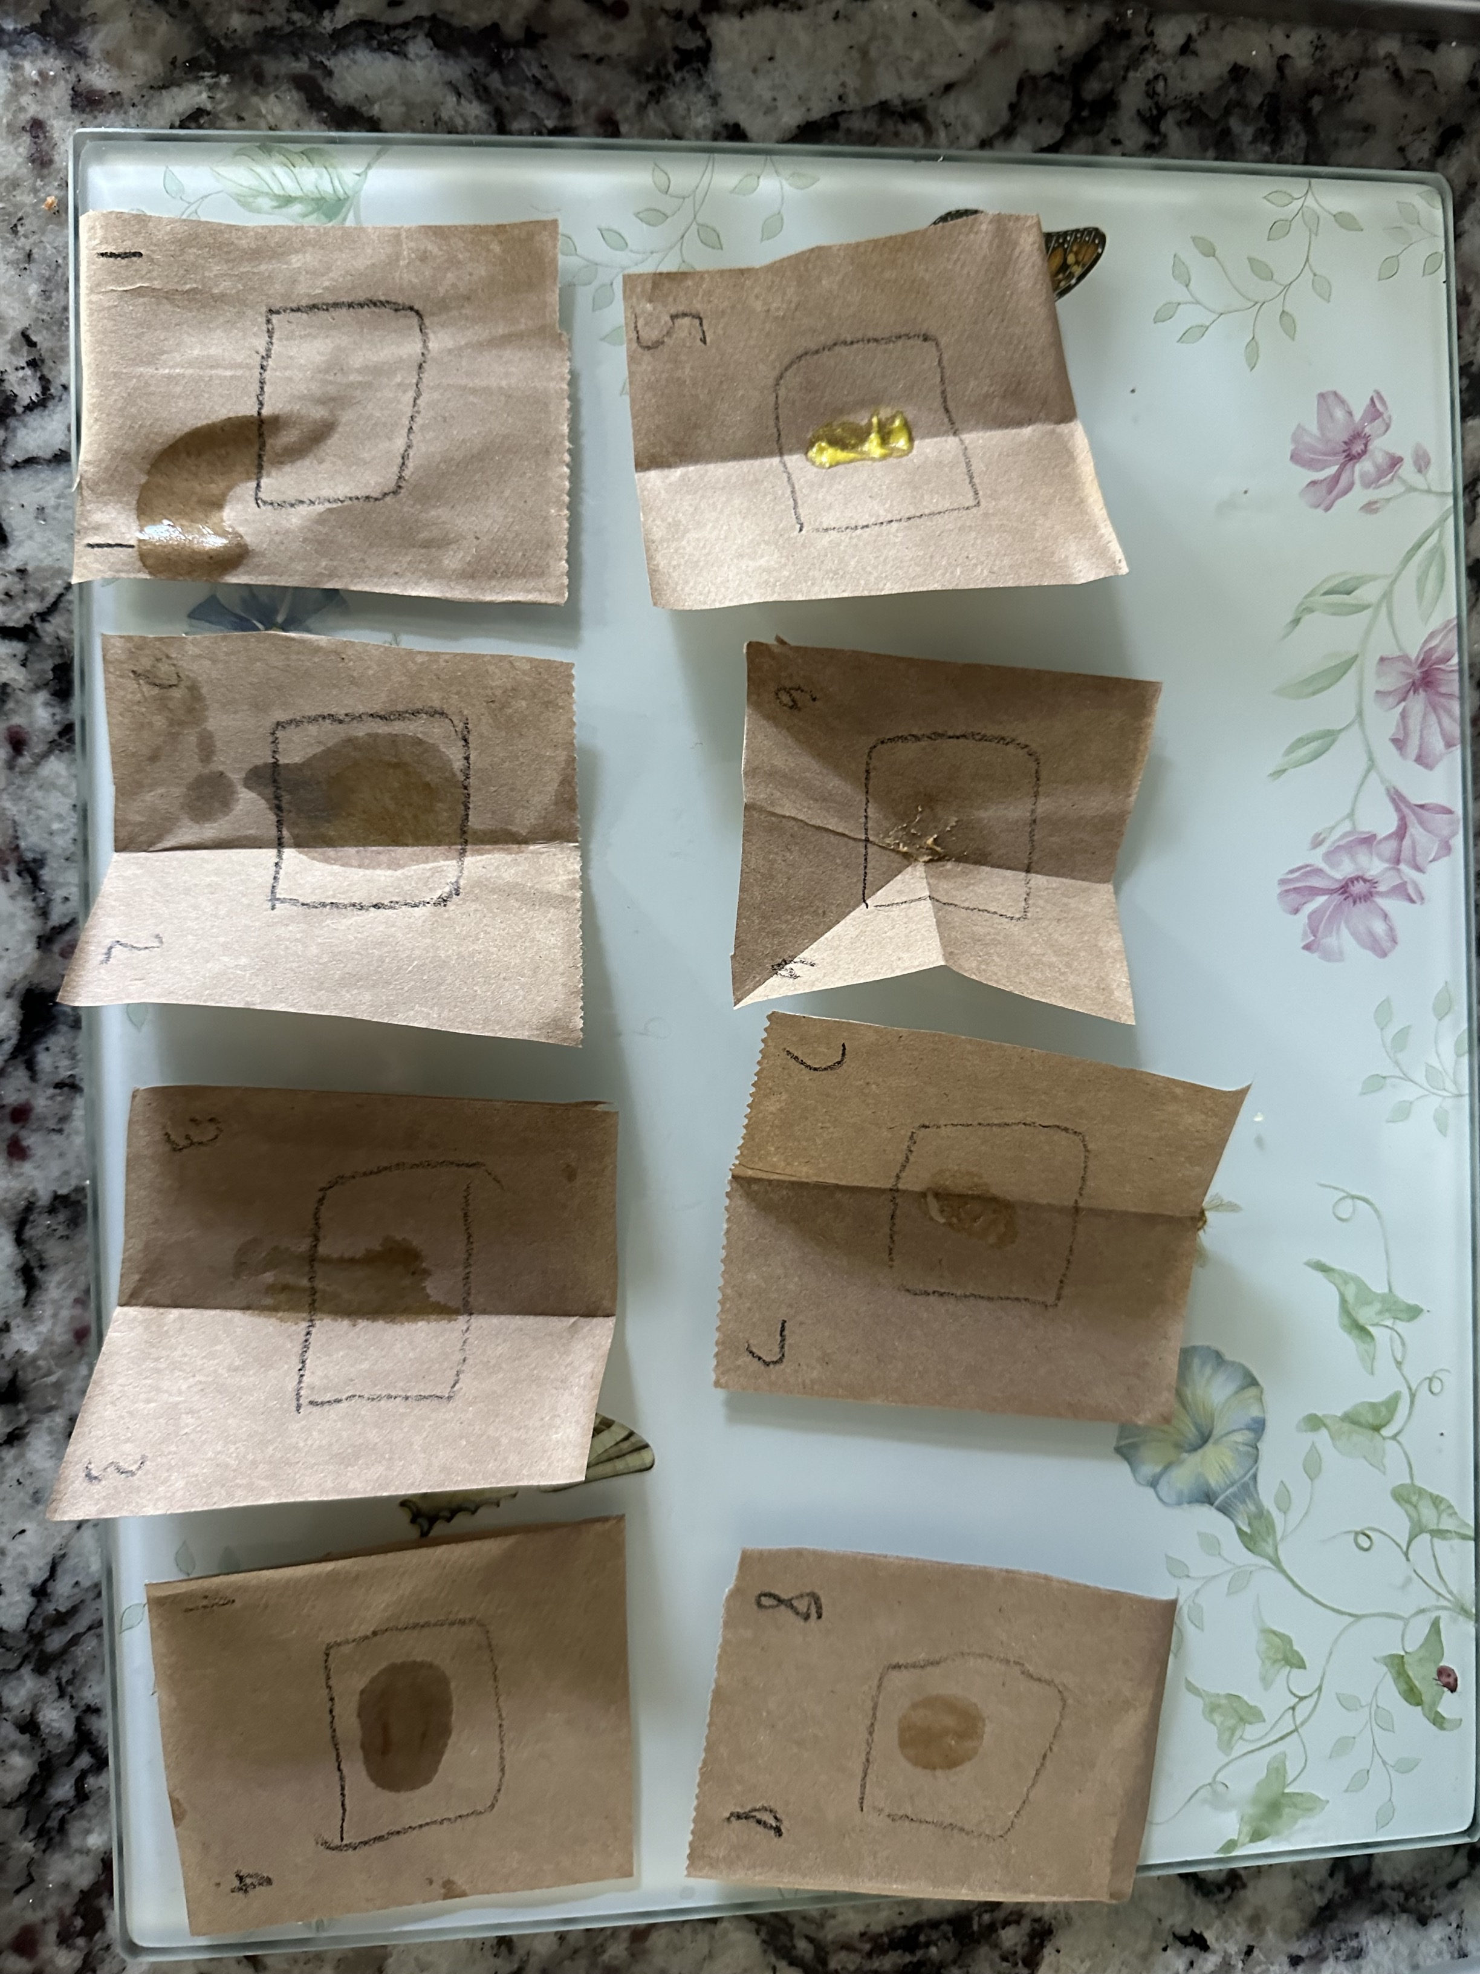

Results for quick test for fats Activity 3, Step 8

***Activity 4: Modeling Gastric Digestion of Protein (1 point)***

|  | **Observation** |
| --- | --- |
| **Test tube 1a $$Albumin+pepsin+HCl+Biuret reagent room temperature incubation$$** | Changed to purple, blue |
| **Test tube 2a $$Albumin+pepsin+water+Biuret reagent room temperature incubation$$** | Changed to purple, material floating |
| **Test tube 1b $$Albumin+pepsin+HCl+Biuret reagent 35 ℃ incubation$$** | Small material floating, cloudy in the middle, seems to be separating the test tube in two parts. |
| **Test tube 2b $$Albumin+pepsin+water+Biuret reagent 35 ℃ incubation$$** | Cloudy with material, no layer splitting. |

**Activity 4 Image: Modeling Gastric Digestion of Proteins, Step 6**

## Image (2 points)

A required part of this laboratory experiment is to capture pictures of the experimental process and results. Click on the icon in the box below to include the required image for this lab.

**Note:** Failure to submit these images will result in a grade of zero for this lab.

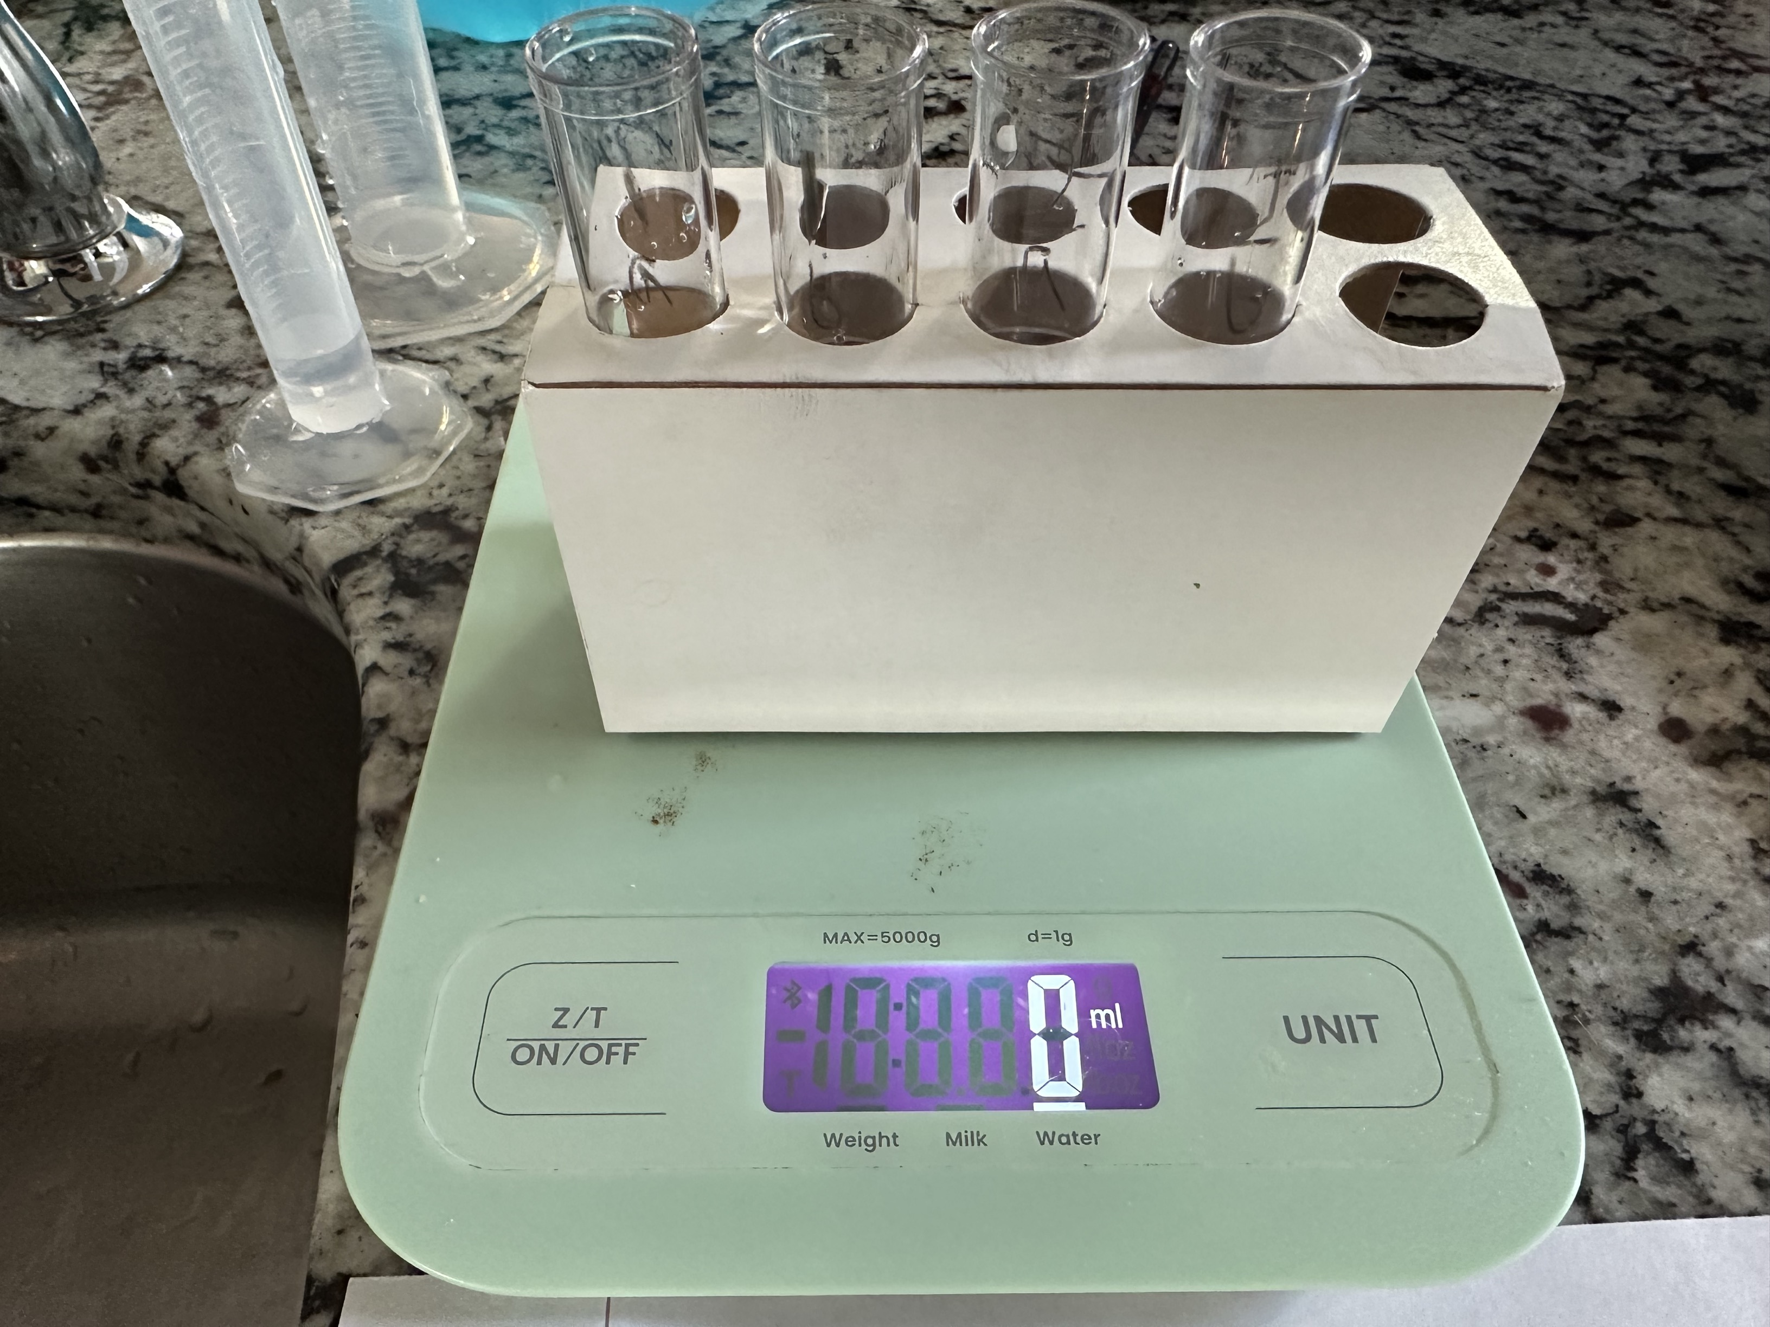

Modeling gastric digestion of proteins for Activity 4, Step 6

**Activity 4 Image: Modeling Gastric Digestion of Proteins, Step 11**

## Image (2 points)

A required part of this laboratory experiment is to capture pictures of the experimental process and results. Click on the icon in the box below to include the required image for this lab.

**Note:** Failure to submit these images will result in a grade of zero for this lab.

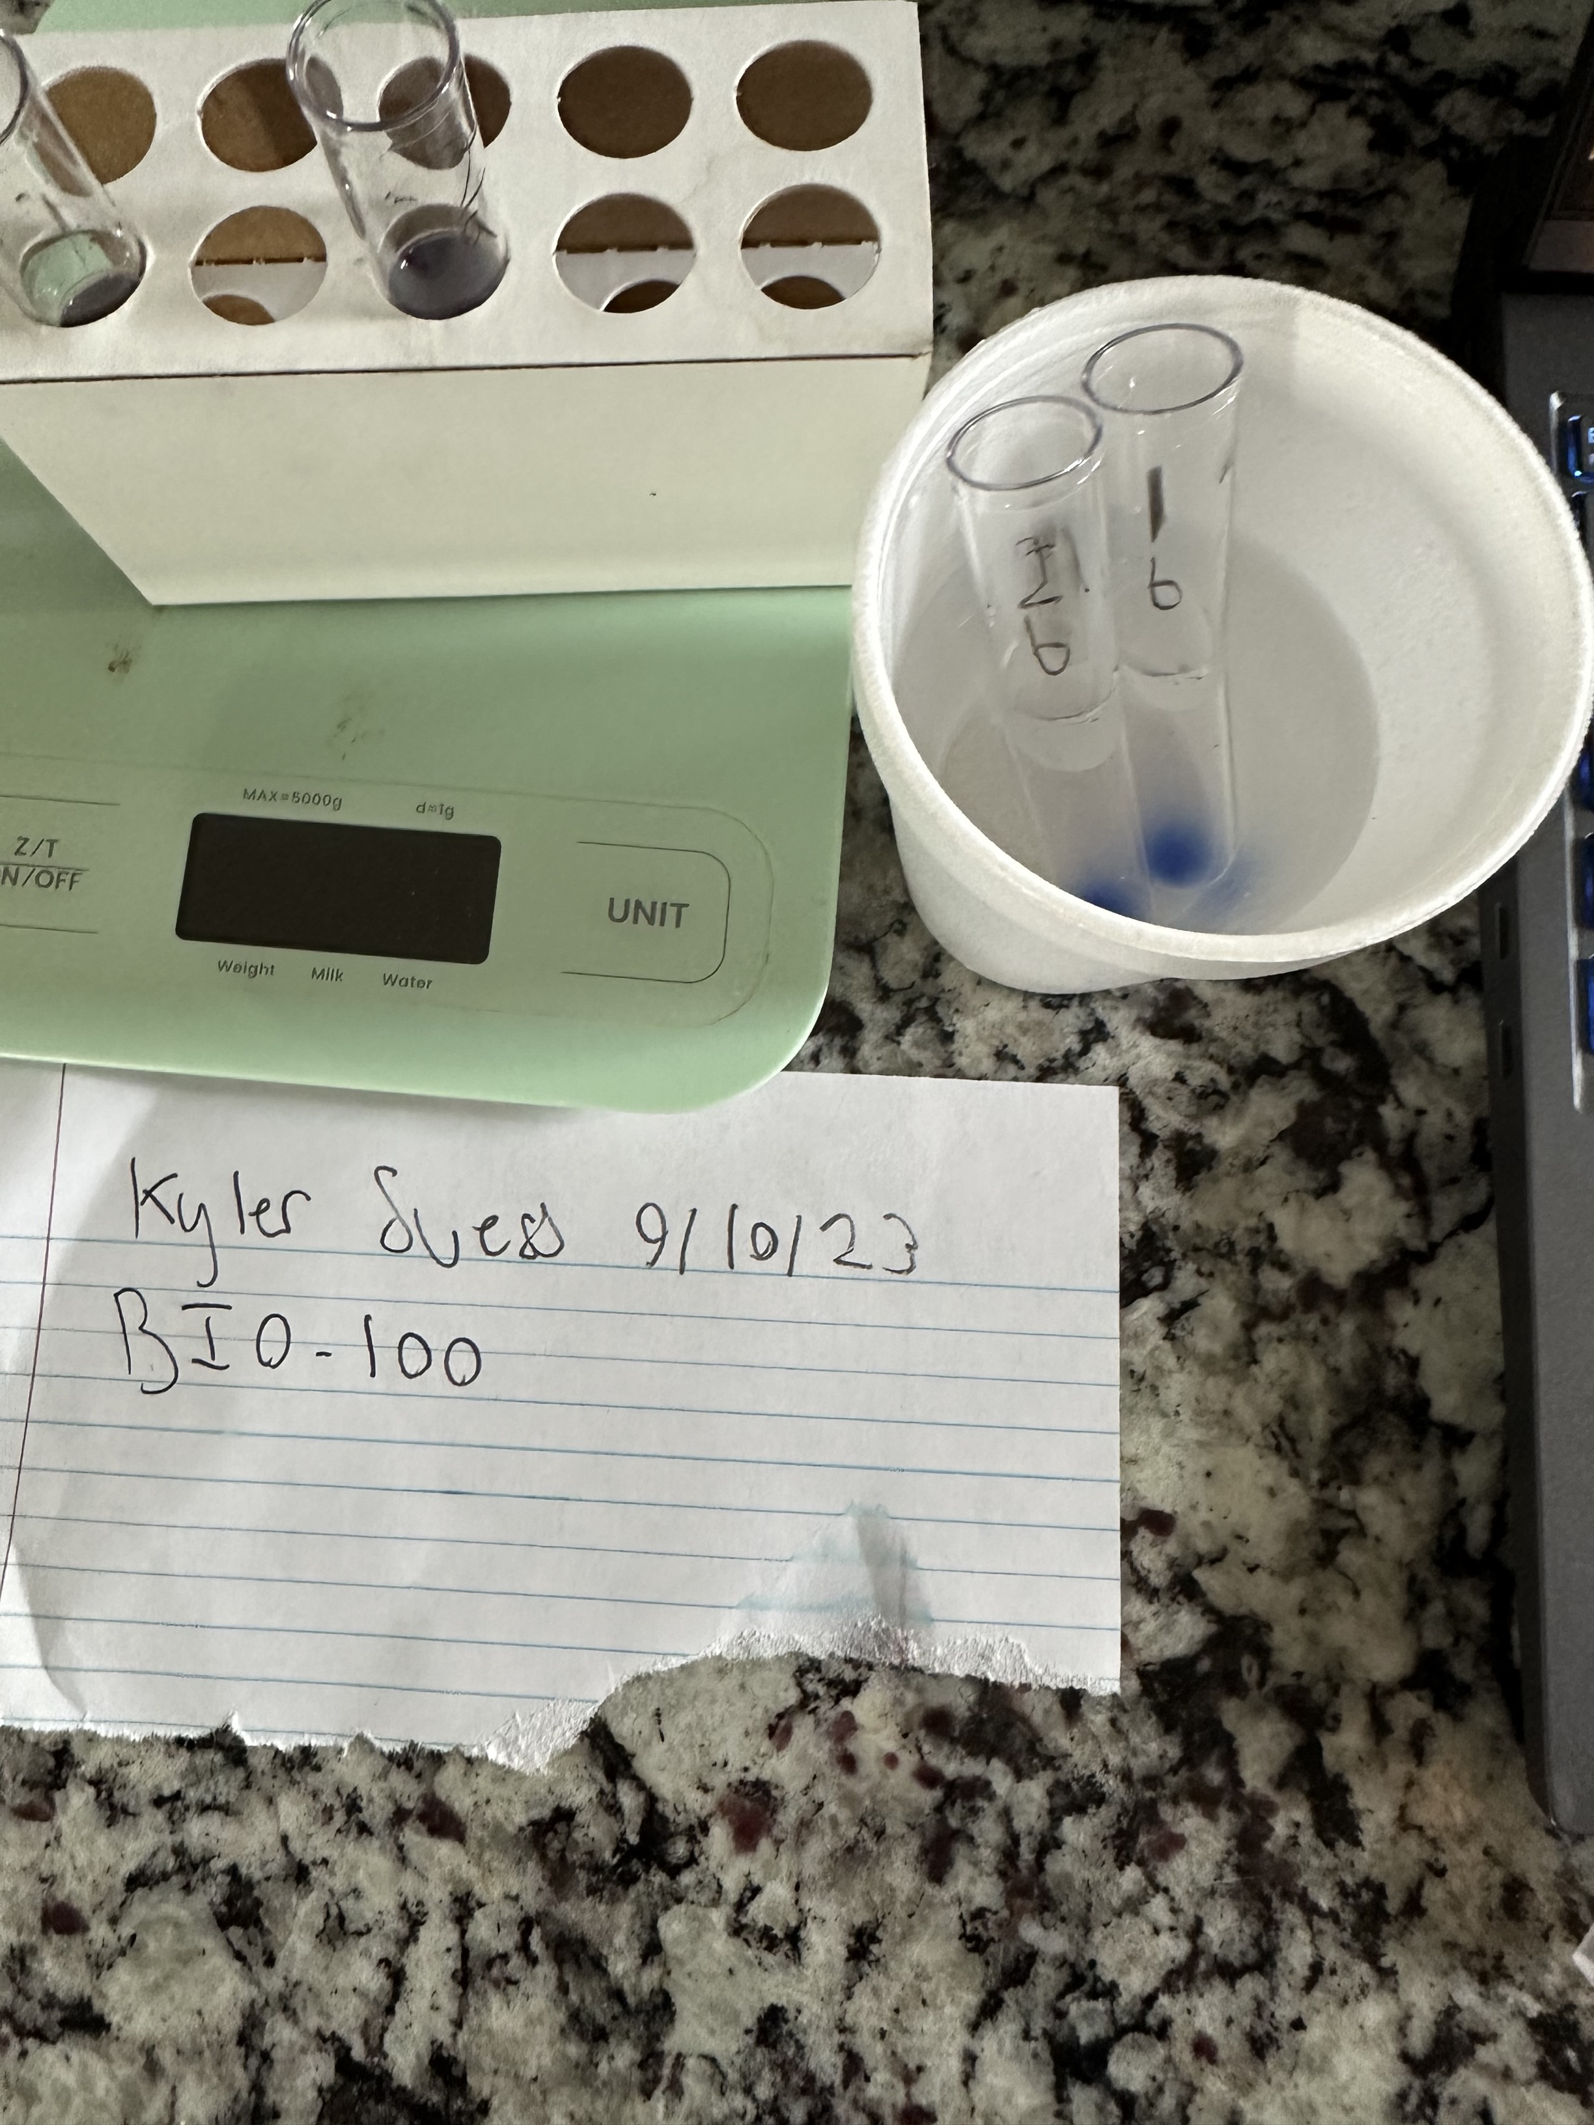

Modeling gastric digestion of proteins for Activity 4, Step 11

***Activity 5: Modeling Salivary Digestion of Starch (1 point)***

|  | **Observation** |
| --- | --- |
| **Cup 1 $$Cracker+distilled water+$$ $$iodine potassium iodide$$** | The iodine turned the water black, but the crackers did not dissolve. |
| **Cup 2 $Cracker+saliva+$ $$iodine potassium iodide$$** | The saliva seemed to have activated the iodine and the crackers turned into a black sludge. |

**Activity 5 Image: Modeling Salivary Digestion of Starch, Step 9**

## Image (2 points)

A required part of this laboratory experiment is to capture pictures of the experimental process and results. Click on the icon in the box below to include the required image for this lab.

**Note:** Failure to submit these images will result in a grade of zero for this lab.

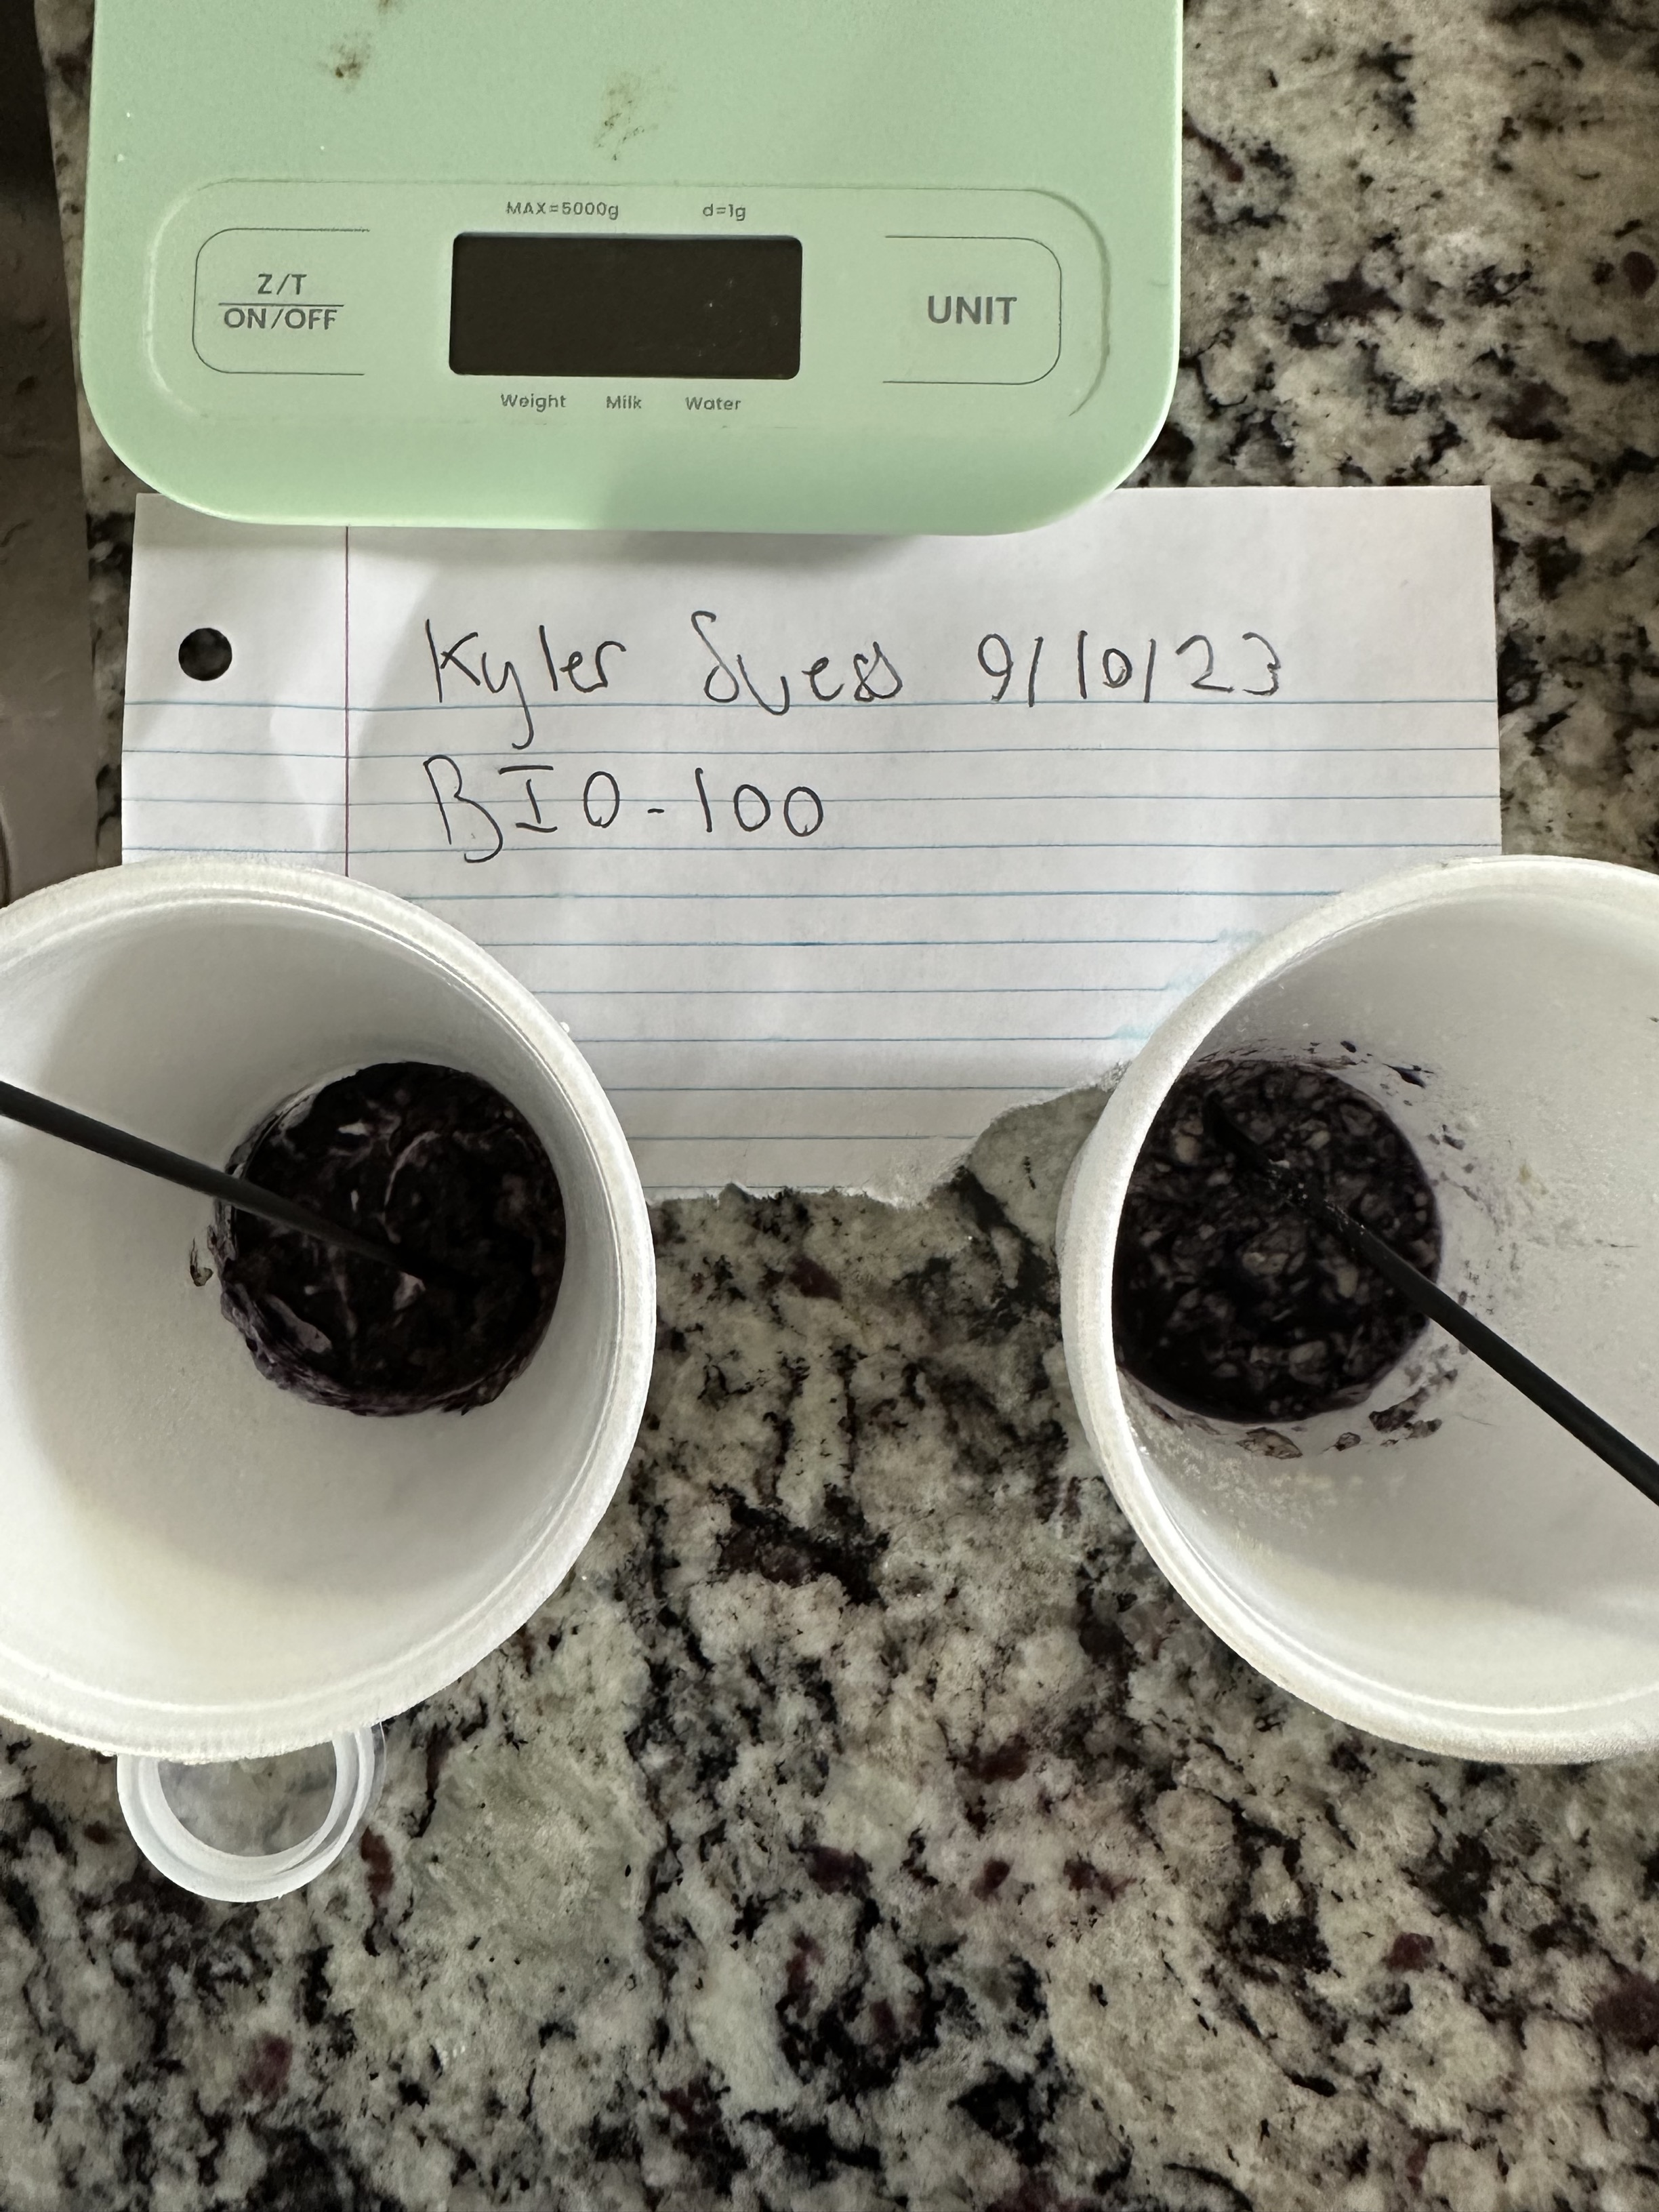

Modeling salivary digestion of starch for Activity 5, Step 9, Cup 1

**Activity 5 Image: Modeling Salivary Digestion of Starch, Step 9**

## Image (2 points)

A required part of this laboratory experiment is to capture pictures of the experimental process and results. Click on the icon in the box below to include the required image for this lab.

**Note:** Failure to submit these images will result in a grade of zero for this lab.



Modeling salivary digestion of starch for Activity 5, Step 9, Cup 2

**LABORATORY REVIEW QUESTIONS**

1. Describe the controls used in the starch test (Activity 1). (.5 point)

The amount of water

1. In the quick test for fats (Activity 3), is there a relationship between the size of the spot and the fat content of the food? Explain your answer. (.5 point)

A smaller spot would mean less fat content, since the fat seeps into the paper and makes it translucent. If you have more fat over a larger area, the spot will be bigger. So, there is a direct relationship between the two.

1. In which test tube(s) did protein digestion occur (Activity 4)? How do you know? (.5 point)

Protein digestion occurred test tubes 2, 3, and 4 because of the small material floating inside each of the test tubes. Test tube 1 did not show any of this.

1. In which cup(s) did starch digestion occur (Activity 5)? How do you know? (.5 point)

Starch digestion occurred in the that contained saliva, as saliva contains the correct enzymes to properly break down food. Whereas the water cup only dissolved the cracker enough to make it soggy.

1. Which enzyme was responsible starch digestion (Activity 5)? Why do you think this is so? (.5 point)

The enzyme responsible for the starch digestion is amylase, the most abundant protein found in human saliva. Amylase allows the starch molecule to break into many smaller disaccharides.

6. Match the polymer (macromolecule) with its correct monomer (building block) by entering the correct letter in the space provided. (2 points)

c. Protein a. glycerol and three fatty acids   
 d. Nucleic acid b. monosaccharides  
 b. Carbohydrates c. amino acids  
 a. Triglyceride d. nucleotides

7. Summarize the functions of each of these classes of molecules in living organisms. (2 points)

A. carbohydrates  
  
The body’s main source of energy. Simple carbs are used immediately, while complex carbs like starch can be used for later use

B. lipids  
  
These act as long-term energy storage. They’re a key part of cell membranes and can also support hormone regulations.

C. proteins

Proteins are the workhorses of the cell. They range from enzymes that speed up reactions, provide structural support, enabling muscle movement and development.

D. nucleic acids

These can be thought of as the instruction manual for cells. They store DNA information crucial for development.

8. Describe the properties that make water essential for life on Earth. (1 point)

Water is an excellent solvent, meaning a lot of substances can dissolved in it, which allows for many of the chemical reactions that are responsible for life. Cohesion and adhesion properties are crucial for nutrient transport in plants. The polarity of water allows it to form hydrogen bonds which gives it unique properties like surface tension.